The Superior University
AI Lab Tasks
Lab 04

Artificial Intelligence (Lab)
Mr. Rasikh Ali
Name: Afaq Akhtar
Roll No:SU92-BSSEM-S25-060

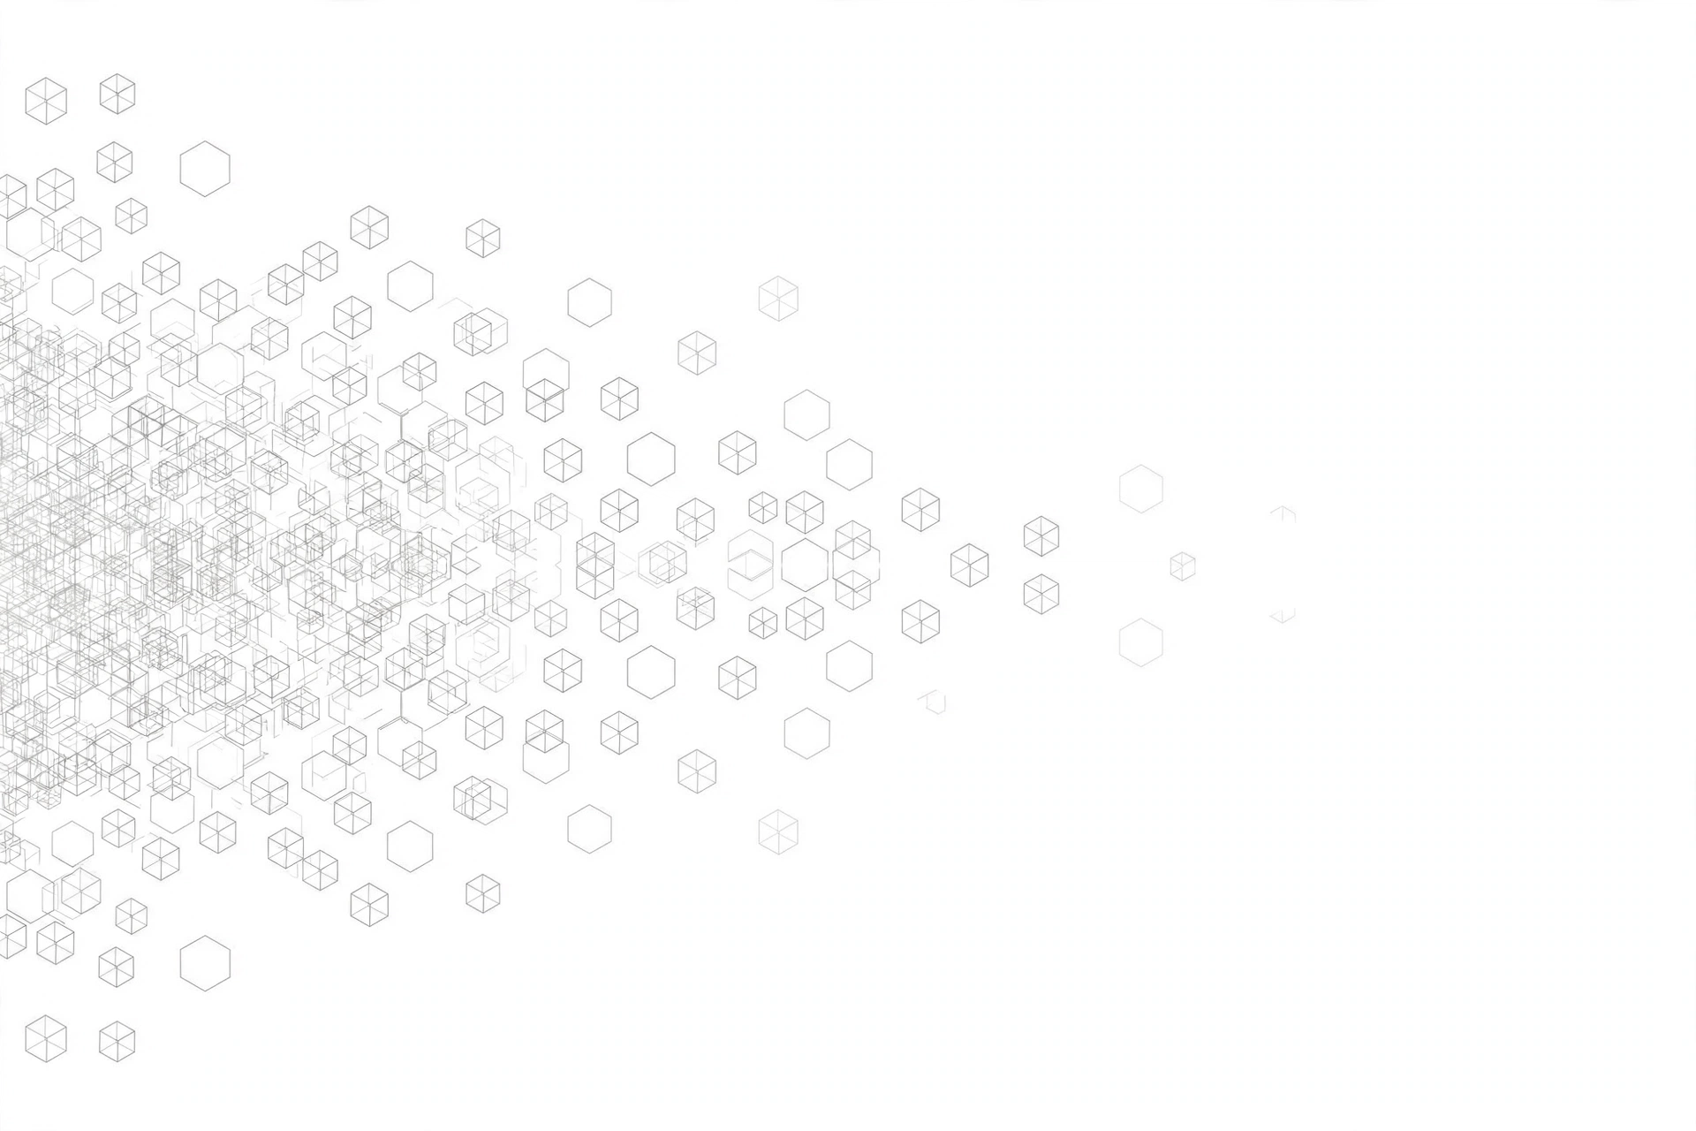
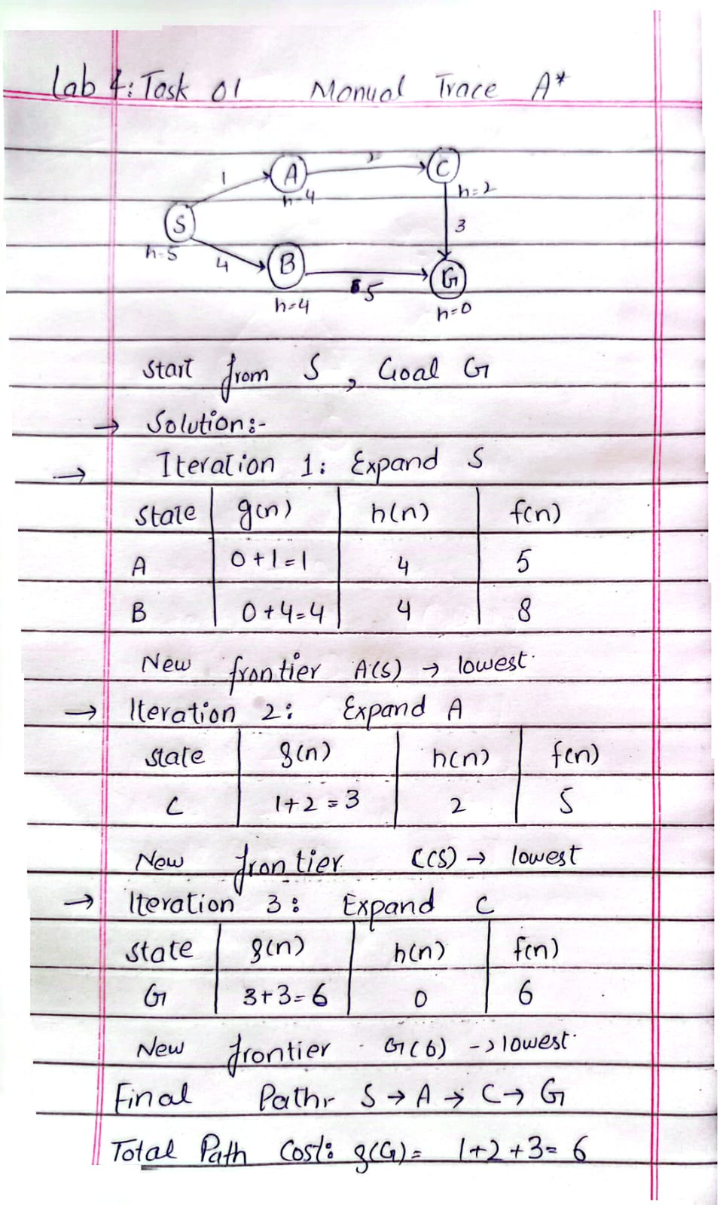
Task 2: A* vs UCS Comparison
The code of Task 2 is attached in the file A Star vs UCS.py
Output Explaination
Queue Display: The program prints the priority queue and visited list at every step. Because the queue is sorted automatically, the node with the lowest cost is always picked first.

A Search Results:* In A*, the program finds the path S → A → C → G with a total cost of 6.

A Expanded Nodes:* A* expands only 3 nodes (S, A, C). The goal node ($G$) is reached and processed, but not expanded further.

UCS Control Run (Heuristic = 0): When we turn off the heuristic (setting all $h=0$ for UCS), it still finds the correct path S → A → C → G with cost 6.

UCS Expanded Nodes: However, UCS expands 4 nodes (S, A, C, B, G). It wastes time expanding node $B$ because it has no heuristic guidance.

Avoiding Bad Paths: The worse route through $B$ (cost 9) is ignored because the better path (cost 6) is already found.

Optimality: Both A* and UCS give the optimal cost of 6, which matches our manual calculation ($1+2+3=6$).
Task 3: Overestimate Experiment:
The code of Task 3 is attached in the file task3.py
Output Explaination
Changing the Heuristic: We change only one value: the heuristic of node $C$ ($h(C)$) is increased from 2 to 10 (which is an overestimate). Everything else stays the same.

Effect on Node C: Node $C$ is reached from $A$ with an actual cost ($g$) of 3, but its new evaluation score ($f$) becomes $3+10=13$. Because of this high $f$-value, $C$ stays at the bottom of the queue.

Processing Node B: Node $B$ has a lower $f$-value ($8$), so $B$ is processed before $C$. Then $B$ reaches the goal $G$ with a total cost of 9.

Wrong Path Selected: The program now shows the path S → B → G with a total cost of 9 instead of the best path.

Expanded Order: The processed nodes are S, A, B, G — and node $C$ is never processed at all.

Conclusion: This proves that if a heuristic overestimates the remaining cost, A* can lose its optimality guarantee and return a more expensive, non-optimal path.

